ARMY PUBLIC SCHOOL , PATIALA
SYLLABUS FOR HALF YEARLY EXAMINATION
CLASS – III
SESSION - 2023-2024
ENGLISH-
Reader
Lesson -3 Save Water, Save the World.
Lesson – 4 A Journey in Space
Lesson -5 Great Scientist- Isaac Newton.
Poem 3- Ferry me Across the Water.
Poem 4- Upside Down.
Grammar
Lesson – 3 Countable Vs Uncountable Noun, Lesson- 4 Noun:Singular and Plural, Lesson -5 Nouns:Gender,Lesson -6 Possessive Nouns,
Lesson -7 Collective nouns, Lesson- 9 Pronouns,Lesson -10 Adjectives,
Lesson- 13 Verbs, Lesson- 14 Tenses (Simple Present Tense)
Writing–
- Formal Letter (Application) (2) Object Writing
Comprehension Passage.

Hindi
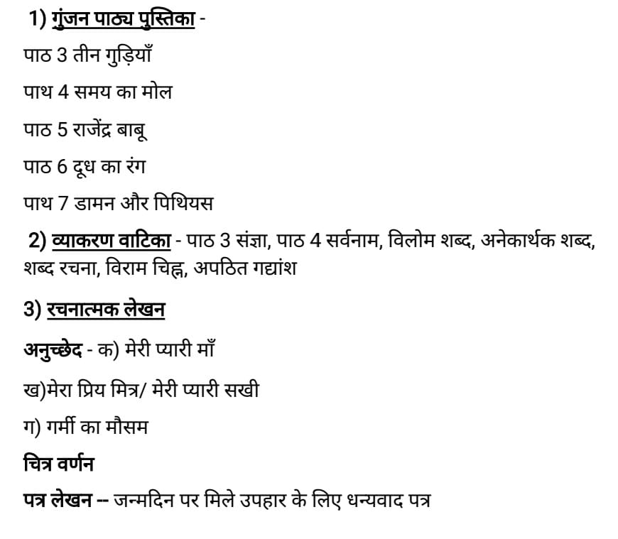

MATHS
Ch -1 Number & Numeration
Ch-2 Roman Numerals
Ch-3 Addition
Ch-4 Subtraction
Ch-5 Multiplication
Ch-6 Division ( from ex 6.1 to 6.6)

EVS
Chapter -4 Animals Around Us
Chapter- 5 Birds – Our Feather Friends
Chapter- 6 The Work Around Us
Chapter-7 The Food We Eat
Chapter-8 Cooking Food
Diagrams :
1) Draw and label the parts of a leaf.[ Ch-3]
2) Label the parts of a bird.[ Ch-5]
3] Draw a plant and label the process of photosynthesis [ Ch-3]
Map Work :
Show the following states in the political map of India in four directions:
NORTH: EAST:
- Himachal Pradesh 1. Arunachal Pradesh
- Punjab 2. Assam
- Haryana 3. West Bengal
SOUTH: WEST:
- Kerala 1. Rajasthan
- Karnataka 2. Gujarat
3.Tamil Nadu 3. Maharashtra
COMPUTER
Ch-2 Windows Operating System
Ch-3 Paint 3 D
Ch-4 Word Processors(MS Word 2016)
G.K. - Page no. 5 to 36
ART/ CRAFT
- Butterfly
- Landscape
- Tree with leaves

